SaaS Service Risk Analysis Report

### Service Overview

Name:

Provider:

Description:

### Risk Identification

#### Security Risks

* Data breaches
* Unauthorized access
* Insecure APIs
* Insufficient encryption

#### Compliance Risks

* Non-compliance with GDPR, HIPAA regulations
* Lack of data residency options
* Limited audit trails

#### Operational Risks

* Downtime and service interruptions
* Data loss or corruption
* Vendor lock-in
* Poor performance

#### Integration Risks

* Compatibility issues with existing systems
* Dependency on third-party integrations
* Data silos

### Risk Assessment

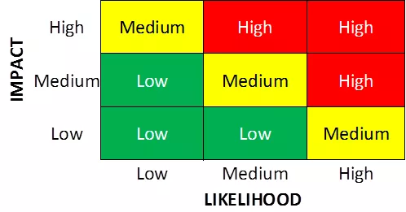

The [name] service is high risk since it has high impact and medium likelihood. It has a very high impact of spilling customer data, including very sensitive PII such as social security numbers, or user credentials that the attacker can use to pivot into company systems. This data breach can occur through a SQL injection that requires some inside knowledge of how the database is organized. Thus, there is a medium level of likelihood that this event could occur.

### Risk Mitigation Strategies

#### Security Measures

* Implement strong encryption protocols
* Enable multi-factor authentication
* Regularly audit access controls

#### Compliance Controls

* Review vendor compliance certifications
* Ensure contractual agreements address compliance requirements
* Monitor regulatory changes and updates

#### Operational Controls

* Implement backup and disaster recovery plans
* Monitor service uptime and performance
* Develop contingency plans for service disruptions

#### Integration Planning

* Conduct thorough testing of integrations
* Establish data mapping and normalization procedures
* Maintain clear communication with integration partners

### Risk Monitoring and Review

* Monitor the service for security events, setting up alerts based on identified risks and saving logs.
* Update this document quarterly. Conduct risk assessments to identify new risks and evaluate the effectiveness of risk mitigation strategies, editing the plan if necessary.

### Reporting and Communication

* Update documentation and present findings of risk assessment to upper management and stakeholders.
* Draft up a list of suggested revisions to the mitigation and disaster plan and present it to upper management, receiving feedback before solidifying and implementing changes.